

SRI MANAKULA VINAYAGAR ENGINEERING COLLEGE

DEPARTMENT OF MANAGEMENT STUDIES

2025 - 2027

MAJOR PROJECT

A STUDY ON FINANCIAL EFFICIENCY AND CORPORATE
PERFORMANCE OF ACCENTURE LTD

SUBMITED BY:

M. ANUSHA

CHAPTER – 1

INTRODUCTION

1.1 Introduction and Theoretical Background of the Study
Financial performance is an important indicator of the financial health and operational efficiency of a business organisation. It helps to understand whether an organisation is effectively utilising its financial resources and generating satisfactory returns. Financial statements such as the Balance Sheet, Income Statement and Cash Flow Statement provide important information for evaluating the financial condition of an organisation.
Financial statement analysis involves the examination and interpretation of financial information over a period of time. Financial ratios are commonly used to evaluate profitability, liquidity and solvency. Comparative statement analysis, common-size statement analysis and trend analysis also help to identify changes in financial performance between different financial years.
The present study focuses on the financial performance of Accenture Private Limited over a selected five-year period. The study examines the financial condition, profitability position, and liquidity and solvency position of the organisation using financial statements and selected financial analysis tools. Accenture's published annual reports provide consolidated financial statements and financial information that can be used for this type of analysis.

1.2 Statement of the Problem
Financial performance may change from year to year due to changes in revenue, expenses, assets, liabilities, profitability and other financial factors. Therefore, analysing the financial position of an organisation over a period of time is important for understanding its financial strengths and weaknesses.
The present study is undertaken to examine the financial performance of Accenture Private Limited over a selected five-year period. The study focuses on the financial condition, profitability position, and liquidity and solvency position of the organisation through financial statement analysis and selected financial ratios.

1.3 Objectives of the Study
The study is carried out with the following objectives:
- To study the financial condition of Accenture Private Limited.
- To analyse the profitability position of the organisation.
- To examine the liquidity and solvency position of Accenture Private Limited.
- To analyse the operational efficiency of Accenture Private Limited.

1.4 Scope of the Study
The scope of the study is based on the objectives of the research. The study focuses on the financial performance of Accenture Private Limited over a selected five-year period.
The study covers:
- The financial condition of Accenture Private Limited.
- The profitability position of the organisation.
- The liquidity position of the organisation.
- The solvency position of the organisation.
- Analysis of selected financial statements and financial ratios.
- Comparison of financial performance over the selected five-year period.
The study is based on secondary financial information obtained from published company reports and other reliable sources.

1.5 Limitations of the Study
- The study is mainly based on secondary financial data.
- The study is limited to the selected five-year period.
- The findings depend on the accuracy and availability of published financial information.
- Financial ratios may be influenced by accounting policies and changes in business conditions.
- The study is limited to financial condition, profitability, liquidity and solvency and does not cover all operational aspects of the organisation.

CHAPTER – 2

REVIEW OF LITERATURE

2.1 Review of Literature
Review 1
Akinbola Olawale and Bolaji Akinbola published a study titled “The Relationship Between Financial Performance, Firm Size, Leverage, and Corporate Social
Responsibility: A Case Study of Accenture Plc.” The study was published in the World Journal of Advanced Research and Reviews in 2024. The study examined Accenture Plc using secondary financial data for the period from 2014 to 2023. Financial performance was measured using Return on Equity, while firm size was measured using total revenue and leverage was measured using the debt-to-assets ratio. The study is relevant to the present research because it directly focuses on Accenture and uses financial indicators such as profitability, revenue and leverage.
Review 2
Accenture's annual reports provide detailed information regarding the financial position and performance of the organisation. The reports contain consolidated balance sheets, income statements, statements of shareholders' equity and cash-flow information. These financial statements provide the basic financial information required for analysing the financial condition and performance of the organisation.
Review 3
Financial statement analysis provides a systematic method for evaluating the financial performance of an organisation. Profitability ratios help to assess the organisation's ability to generate profit, while liquidity ratios help to evaluate its ability to meet shortterm obligations. Solvency ratios help to understand the long-term financial stability of an organisation.

Review 4
Comparative and trend analysis can be used to identify changes in financial performance over a number of financial years. Comparing revenue, profit, assets, liabilities and equity across different years helps in understanding the direction of financial performance and identifying significant changes in the organisation's financial position.
Review 5
The present study focuses specifically on the financial condition, profitability, liquidity and solvency position of Accenture Private Limited. The study uses financial statement information and financial ratios to evaluate the organisation's financial performance over a selected five-year period.

2.2 COMPANY PROFILE
Accenture PLC
Accenture is a global professional services organisation operating in consulting, technology and business transformation. The organisation provides services relating to technology, digital transformation, cloud, artificial intelligence, data, cybersecurity and other business solutions.
Accenture publishes annual reports containing financial statements and other information relating to its financial and operating performance. The company's official annual-report archive provides reports for several financial years, including fiscal years 2021, 2022, 2023 and 2024, while the 2025 annual report provides the latest financial information used as a source for the study.

2.3 COMPANY OVERVIEW
Particulars | Details
Company  Name | Accenture Ltd.
Industry | Information Technology (IT) & Consulting Services
Founded | 1989
Headquarters | Dublin, Ireland
CEO | Julie Sweet
Business Areas | Strategy & Consulting, Technology, Operations, Song and  Industry X
Global Presence | More than 120 countries
Employees | More than 800,000
Company  Status | Public Company

CHAPTER – 3

RESEARCH METHODOLOGY

3.1 Meaning of Research Methodology
Research methodology refers to the systematic process followed by a researcher to collect, organise, analyse and interpret information for achieving the objectives of a study. It provides a structured framework for conducting research in a logical and systematic manner.
In the present study, research methodology explains the method used to collect and analyse financial information relating to Accenture Private Limited. Since the study focuses on financial performance, the methodology mainly involves the collection of secondary financial data and the application of appropriate financial analysis techniques.

3.2 Research Design
The present study follows a descriptive and analytical research design.
The descriptive approach is used to present the financial information of Accenture Private Limited for the selected five-year period. The analytical approach is used to examine and interpret the financial condition, profitability, liquidity and solvency position of the organisation.
The study compares financial information across different years and applies selected financial ratios and statement-analysis techniques to understand changes in financial performance.

3.3 Collection of Data
The present study is based entirely on secondary data.
The major source of financial information is the published annual reports and financial statements of Accenture. Accenture's official annual-report page provides access to previous annual reports, including Fiscal 2021, Fiscal 2022, Fiscal 2023 and Fiscal 2024. The Fiscal 2025 annual report provides the latest annual financial statements.

The study uses relevant financial information such as:
- Current Assets
- Current Liabilities
- Total Assets
- Total Liabilities
- Shareholders' Equity
- Revenue
- Operating Profit / Operating Income
- Net Profit / Net Income
- Debt
- Other relevant financial statement information
The collected data will be organised in tables and used for calculating the selected financial ratios.

3.4 Tools for Analysis
The following tools are used for analysing the financial performance of Accenture Private Limited:

1. Comparative Statement Analysis
Comparative statement analysis is used to compare financial figures between different years and identify increases or decreases in financial items.

2. Common-size Statement Analysis
Common-size statement analysis expresses individual financial statement items as percentages of a common base. It helps to understand the relative composition of the financial statements.

3. Trend Analysis
Trend analysis is used to identify the direction and pattern of changes in the financial performance of the organisation over the selected five-year period.

4. Current Ratio
Current Ratio measures the ability of an organisation to meet its short-term obligations using its current assets.
Formula:

Current Ratio = Current Assets / Current Liabilities

5. Quick Ratio
Quick Ratio measures the ability of an organisation to meet its short-term obligations using its most liquid assets.
Formula:

Quick Ratio = Quick Assets / Current Liabilities

6. Net Profit Ratio
Net Profit Ratio measures the percentage of net profit earned in relation to revenue.
Formula:

Net Profit Ratio = (Net Profit / Revenue) × 100

7. Operating Profit Ratio
Operating Profit Ratio measures the percentage of operating profit earned in relation to revenue.
Formula:

Operating Profit Ratio = (Operating Profit / Revenue) × 100

8. Return on Assets (ROA)
Return on Assets measures the ability of the organisation to generate profit from its assets.
Formula:

ROA = (Net Profit / Average Total Assets) × 100

9. Return on Equity (ROE)
Return on Equity measures the return generated on shareholders' equity.
Formula:

ROE = (Net Profit / Average Shareholders' Equity) × 100

10. Return on Capital Employed (ROCE)
Return on Capital Employed measures the efficiency with which capital employed is used to generate operating returns.
Formula:

ROCE = (EBIT / Capital Employed) × 100

11. Debt–Equity Ratio
Debt–Equity Ratio measures the relationship between borrowed funds and shareholders' equity.
Formula:

Debt–Equity Ratio = Total Debt / Shareholders' Equity

12. Asset Turnover Ratio
Asset Turnover Ratio measures how efficiently the assets of an organisation are used to generate revenue.
Formula:

Asset Turnover Ratio = Revenue / Average Total Assets
The above tools help in evaluating the three major objectives of the study, namely the financial condition, profitability position, and liquidity and solvency position of Accenture Private Limited.

CHAPTER – 4

DATA ANALYSIS AND INTERPRETATION
ACCENTURE LTD - FINANCIAL EFFICIENCY AND CORPORATE PERFORMANCE (FY2021-FY2025)
4.1 BALANCE SHEET - COMPARATIVE & COMMON SIZE ANALYSIS
4.1.1 COMPARATIVE STATEMENT ANALYSIS - ASSETS, LIABILITIES & EQUITY

Particulars | FY2021 (Cr) | FY2022 (Cr) | FY2023 (Cr) | FY2024 (Cr) | FY2025 (Cr)
ASSETS
Current Assets
Cash & Equivalents | 59,625.22 | 62,745.47 | 74,778.90 | 41,980.49 | 101,204.51
Receivables | 71,013.03 | 93,657.16 | 101,087.04 | 114,628.94 | 132,118.89
Other Current Assets | 13,921.38 | 15,462.14 | 17,441.84 | 18,358.15 | 21,485.31
Total Current Assets | 144,559.63 | 171,864.77 | 193,307.78 | 174,967.58 | 254,808.70
Non-Current Assets
PP&E, Net | 11,964.97 | 13,194.64 | 12,649.18 | 12,760.06 | 13,810.25
Goodwill & Intangible Assets | 81,215.45 | 121,583.10 | 153,108.99 | 198,423.63 | 198,696.82
Other Non-Current Assets | 78,430.65 | 75,228.05 | 65,299.58 | 82,990.95 | 109,251.41
Total Non-Current Assets | 171,611.07 | 209,905.79 | 231,057.76 | 294,174.64 | 321,758.48
TOTAL ASSETS | 315,170.70 | 381,770.56 | 424,365.54 | 469,142.22 | 576,567.18
LIABILITIES & EQUITY
Current Liabilities | 114,670.02 | 139,359.11 | 148,887.92 | 159,183.14 | 179,438.33
Long-Term Liabilities | 53,797.78 | 55,611.69 | 56,033.74 | 65,330.32 | 112,869.92
Total Liabilities | 168,467.80 | 194,970.80 | 204,921.66 | 224,513.46 | 292,308.25
Shareholders' Equity | 146,702.90 | 186,799.76 | 219,443.88 | 244,628.76 | 284,258.93
TOTAL LIABILITIES & EQUITY | 315,170.70 | 381,770.56 | 424,365.54 | 469,142.22 | 576,567.18

Interpretation:
- Total assets grew 82.8% from FY2021 to FY2025
- Current assets grew 76.3%; Non-current assets grew 87.4%
- Goodwill & Intangible Assets represent 34.46% of total assets - acquisition-driven growth
- Liabilities grew 73.5%; Equity grew 93.8% - equity base strengthening
- Balanced capital structure maintained throughout period
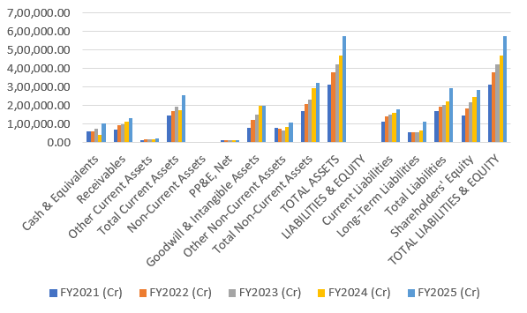

4.2 BALANCE SHEET - COMMON SIZE ANALYSIS
ASSETS, LIABILITIES & EQUITY - COMMON SIZE STATEMENT (%)

Particulars | FY2021 | FY2022 | FY2023 | FY2024 | FY2025
ASSETS
Current Assets
Cash & Equivalents | 18.92% | 16.45% | 17.63% | 8.95% | 17.55%
Receivables | 22.54% | 24.54% | 23.81% | 24.43% | 22.91%
Other Current Assets | 4.42% | 4.05% | 4.11% | 3.91% | 3.73%
Total Current Assets | 45.88% | 45.04% | 45.55% | 37.29% | 44.19%
Non-Current Assets
PP&E, Net | 3.80% | 3.46% | 2.98% | 2.72% | 2.40%
Goodwill & Intangible Assets | 25.76% | 31.83% | 36.07% | 42.29% | 34.46%
Other Non-Current Assets | 24.88% | 19.71% | 15.39% | 17.69% | 18.95%
Total Non-Current Assets | 54.44% | 55.00% | 54.44% | 62.70% | 55.81%
TOTAL ASSETS | 100.0% | 100.0% | 100.0% | 100.0% | 100.0%
LIABILITIES & EQUITY
Current Liabilities | 36.38% | 36.48% | 35.14% | 33.93% | 31.12%
Long-Term Liabilities | 17.07% | 14.56% | 13.23% | 13.92% | 19.58%
Total Liabilities | 53.45% | 51.04% | 48.37% | 47.85% | 50.70%
Shareholders' Equity | 46.55% | 48.96% | 51.63% | 52.15% | 49.30%
TOTAL LIABILITIES & EQUITY | 100.0% | 100.0% | 100.0% | 100.0% | 100.0%

Interpretation:
- Current assets' share of total assets fell from 45.88% (FY2021) to a low of 37.29% (FY2024) before recovering to 44.19% (FY2025)
- Goodwill & Intangible Assets rose sharply from 25.76% to a peak of 42.29% of total assets (FY2024), settling at 34.46% - reflecting sustained acquisition-led growth
- Cash & Equivalents' share of assets dropped sharply to 8.95% in FY2024 before rebounding to 17.55% in FY2025
- Receivables remained broadly stable at 22-25% of total assets throughout the period
- Shareholders' Equity share improved from 46.55% to a peak of 52.15% (FY2024) before easing to 49.30% (FY2025) as fresh debt was raised
- Overall, the asset mix shifted structurally toward intangibles, signalling a strategy increasingly reliant on acquired capabilities rather than organic PP&E

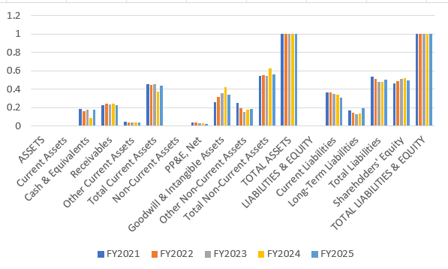

4.2 LIQUIDITY ANALYSIS
Liquidity analysis measures the company's ability to meet short-term obligations using current assets.

- CURRENT RATIO ANALYSIS

Particulars | FY2021 | FY2022 | FY2023 | FY2024 | FY2025
Current Assets (Cr) | 143,559.63 | 171,864.77 | 193,307.78 | 174,967.58 | 254,808.70
Current Liabilities (Cr) | 114,670.02 | 139,359.11 | 148,887.92 | 159,183.14 | 179,438.33
Current Ratio | 1.25:1 | 1.23:1 | 1.30:1 | 1.10:1 | 1.42:1
Year-on-Year Change (%) | Base | ↓ 1.60% | ↑ 5.69% | ↓ 15.38% | ↑ 29.09%

Interpretation:
- Benchmark: 1.5:1 is ideal; 1.0:1 is minimum
- FY2021-FY2023: Strong position (1.23-1.30:1)
- FY2024: Critical dip to 1.10:1 (below benchmark)
- FY2025: Recovery to 1.42:1 (strong position)
- Liquidity restored in latest year
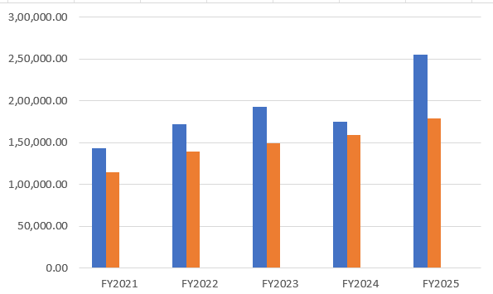

- QUICK RATIO ANALYSIS

Particulars | FY2021 | FY2022 | FY2023 | FY2024 | FY2025
Current Assets (Cr) | 143,559.63 | 171,864.77 | 193,307.78 | 174,967.58 | 254,808.70
Less: Inventory (Cr) | 12,890.04 | 15,430.54 | 17,404.02 | 18,312.89 | 21,485.31
Quick Assets (Cr) | 130,669.59 | 156,434.23 | 175,903.76 | 156,654.69 | 233,375.82
Current Liabilities (Cr) | 114,670.02 | 139,359.11 | 148,887.92 | 159,183.14 | 179,438.33
Quick Ratio | 1.14:1 | 1.12:1 | 1.18:1 | 0.98:1 | 1.30:1
Year-on-Year Change (%) | Base | ↓ 1.75% | ↑ 5.36% | ↓ 16.95% | ↑ 32.65%
Interpretation:
- Benchmark: 1.0:1 is minimum for immediate liquidity
- FY2021-FY2023: Strong (1.12-1.18:1)
- FY2024: Below 1.0 at 0.98:1 (concern)
- FY2025: Excellent at 1.30:1 (best position)
- Immediate liquidity restored successfully
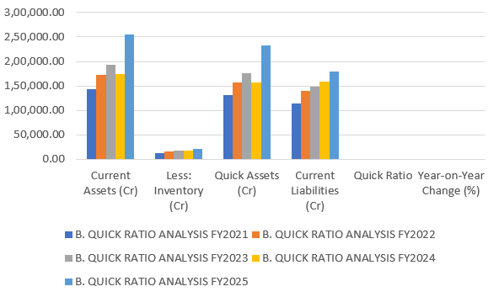

- CASH POSITION ANALYSIS

Year | Cash & Equivalents (Cr) | % of Current Assets | % of Total Assets | Year-on-Year Change (%)
FY2021 | 59,625.22 | 41.51% | 18.92% | Base
FY2022 | 62,745.47 | 36.49% | 16.69% | ↑ 5.23%
FY2023 | 74,778.90 | 38.71% | 17.65% | ↑ 19.23%
FY2024 | 41,980.49 | 23.98% | 8.95% | ↓ 43.91%
FY2025 | 101,204.51 | 39.73% | 17.55% | ↑ 141.01%

Interpretation:
- Cash balances were volatile across the period, ranging from a low of Rs.41,980.49 Cr (FY2024) to a high of Rs.101,204.51 Cr (FY2025)
- FY2024 saw a sharp 43.91% decline in cash, coinciding with the dip in current and quick ratios that year
- FY2025 recorded a dramatic 141.01% rebound in cash, restoring liquidity buffers
- Cash consistently formed a minor share of total assets (under 19%), indicating funds are largely deployed rather than held idle
- The FY2024 trough followed by the FY2025 surge suggests active treasury management, likely aided by the debt raised during the year
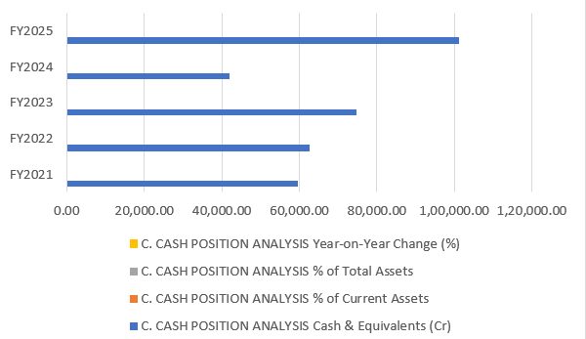

4.3 PROFITABILITY ANALYSIS
Profitability analysis measures the company's ability to generate profits from its operations and assets.

  - GROSS PROFIT ANALYSIS

Year | Revenue (Cr) | Cost of Goods Sold (Cr) | Gross Profit (Cr) | Gross Profit Margin (%) | Change (%)
FY2021 | 3,68,879.04 | 2,65,312.55 | 1,03,566.49 | 28.06% | Base
FY2022 | 4,89,674.72 | 3,57,663.38 | 1,32,011.34 | 26.96% | ↓ 1.10%
FY2023 | 5,09,836.43 | 3,74,633.10 | 1,35,203.33 | 26.52% | ↓ 0.44%
FY2024 | 5,16,238.37 | 3,81,415.87 | 1,34,822.50 | 26.12% | ↓ 0.40%
FY2025 | 5,54,250.28 | 4,13,589.71 | 1,40,660.57 | 25.37% | ↓ 0.75%

Interpretation:
- Revenue grew consistently every year, rising from Rs.3,68,879.04 Cr (FY2021) to Rs.5,54,250.28 Cr (FY2025), a 50.3% increase
- Gross profit margin declined steadily each year, from 28.06% (FY2021) to 25.37% (FY2025)
- Cost of Goods Sold grew faster than revenue in relative terms, indicating rising delivery/input costs
- Absolute gross profit still grew from Rs.1,03,566.49 Cr to Rs.1,40,660.57 Cr, driven by revenue scale despite margin compression
- The steady year-on-year margin erosion points to sustained pricing or wage-cost pressure rather than a one-off event
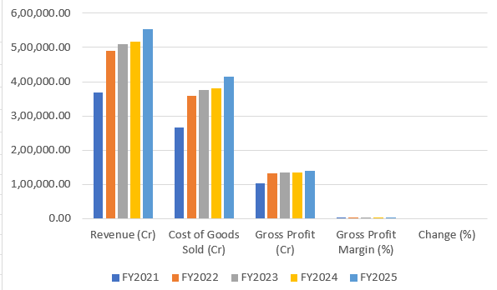

  - OPERATING PROFIT ANALYSIS

Year | Revenue (Cr) | Operating Expenses (Cr) | Operating Profit (Cr) | Operating Profit Margin (%) | Change (%)
FY2021 | 3,68,879.04 | 3,13,241.88 | 55,637.16 | 15.08% | Base
FY2022 | 4,89,674.72 | 4,15,211.96 | 74,462.76 | 15.21% | ↑ 0.13%
FY2023 | 5,09,836.43 | 4,39,746.71 | 70,089.72 | 13.74% | ↓ 1.47%
FY2024 | 5,16,238.37 | 4,39,903.41 | 76,334.96 | 14.79% | ↑ 1.05%
FY2025 | 5,54,250.28 | 4,72,905.12 | 81,345.16 | 14.68% | ↓ 0.11%

Interpretation:
- Operating profit margin moved in a narrow band, from 15.08% (FY2021) down to 13.74% (FY2023) and back up to 14.68% (FY2025)
- FY2023 was the weakest year for operating efficiency, with margin falling 1.47 percentage points
- Operating expenses broadly tracked revenue growth, keeping margin swings modest despite the top-line more than doubling
- FY2024 saw a partial recovery in margin (+1.05%) before a marginal dip in FY2025
- Overall operating performance has been relatively stable, suggesting reasonable cost discipline despite gross margin pressure
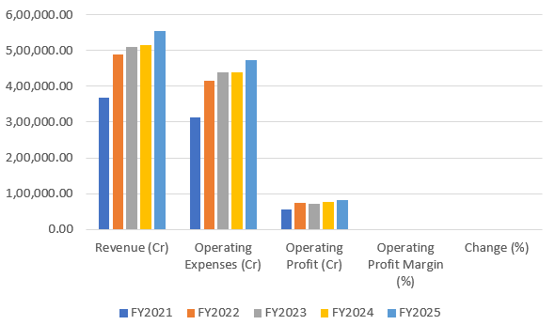

  - NET PROFIT ANALYSIS

Year | Revenue (Cr) | Operating Profit (Cr) | Finance Cost (Cr) | Net Profit (Cr) | Net Profit Margin (%) | Change (%)
FY2021 | 3,68,879.04 | 55,637.16 | 911.62 | 43,727.54 | 11.85% | Base
FY2022 | 4,89,674.72 | 74,462.76 | 1,198.53 | 55,562.23 | 11.35% | ↓ 0.50%
FY2023 | 5,09,836.43 | 70,089.72 | 1,376.62 | 55,713.10 | 10.92% | ↓ 0.43%
FY2024 | 5,16,238.37 | 76,334.96 | 1,754.75 | 59,020.21 | 11.43% | ↑ 0.51%
FY2025 | 5,54,250.28 | 81,345.16 | 2,038.42 | 62,306.74 | 11.24% | ↓ 0.19%

Interpretation:
- Net profit rose from Rs.43,727.54 Cr to Rs.62,306.74 Cr, a 42.5% increase over the five years
- Net profit margin drifted down slightly from 11.85% to 11.24%, staying within a narrow 10.9%-11.9% range
- Finance costs more than doubled, from Rs.911.62 Cr to Rs.2,038.42 Cr, reflecting the rising debt taken on in FY2024-FY2025
- Despite the margin dip, absolute profit growth was consistent, underscoring resilient bottom-line performance
- Rising finance costs are the key drag to monitor as the debt burden increases going forward
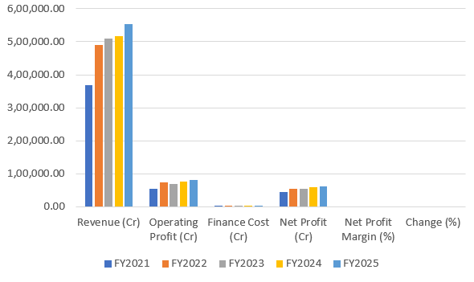

- RETURN ON ASSETS (ROA) ANALYSIS

Year | Net Profit (Cr) | Total Assets (Cr) | Average Total Assets (Cr) | ROA (%) | Change (%)
FY2021 | 43,727.54 | 315,170.70 | 315,170.70 | 13.87% | Base
FY2022 | 55,562.23 | 381,770.56 | 348,470.63 | 15.95% | ↑ 2.08%
FY2023 | 55,713.10 | 424,365.54 | 403,068.05 | 13.82% | ↓ 2.13%
FY2024 | 59,020.21 | 469,142.22 | 446,753.88 | 13.21% | ↓ 0.61%
FY2025 | 62,306.74 | 576,567.18 | 522,854.70 | 11.91% | ↓ 1.30%

Interpretation:
- ROA declined from 13.87% (FY2021) to 11.91% (FY2025), after peaking at 15.95% in FY2022
- The decline indicates total assets grew faster than net profit, largely due to sizeable goodwill and intangible additions from acquisitions
- Every year since FY2022 has shown a consecutive fall in ROA, suggesting acquired assets have yet to generate proportionate returns
- The FY2025 dip to 11.91% is the steepest single-year fall (-1.30%) in the series
- Asset efficiency is a key area to watch, as continued acquisition-led growth without matching profit growth would further dilute returns
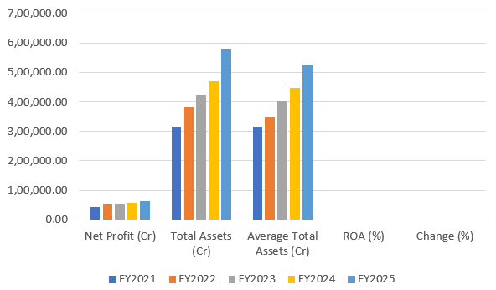

- RETURN ON EQUITY (ROE) ANALYSIS

Year | Net Profit (Cr) | Shareholders' Equity (Cr) | Average Equity (Cr) | ROE (%) | Change (%)
FY2021 | 43,727.54 | 146,702.90 | 146,702.90 | 29.81% | Base
FY2022 | 55,562.23 | 186,799.76 | 166,751.33 | 33.32% | ↑ 3.51%
FY2023 | 55,713.10 | 219,443.88 | 203,121.82 | 27.41% | ↓ 5.91%
FY2024 | 59,020.21 | 244,628.76 | 232,036.32 | 25.43% | ↓ 1.98%
FY2025 | 62,306.74 | 284,258.93 | 264,443.85 | 23.55% | ↓ 1.88%

Interpretation:
- ROE declined from 29.81% (FY2021) to 23.55% (FY2025), after peaking at 33.32% in FY2022
- Despite the downward trend, ROE remains healthy and well above typical cost-of-equity benchmarks
- The decline is driven by equity growing faster (93.8% over the period) than net profit (42.5%), diluting returns per unit of equity
- FY2023 saw the sharpest single-year drop (-5.91%), aligning with softer net profit growth that year
- The consistent downward trend suggests the company is relying more on retained equity than leverage to fund growth, which is safer but less return-accretive
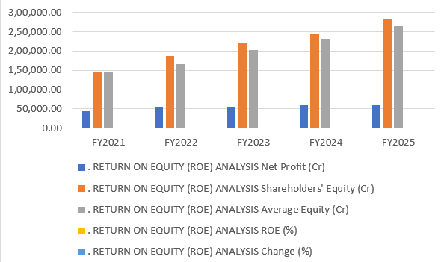

4.4 SOLVENCY ANALYSIS
Solvency analysis measures the company's long-term financial stability and ability to meet long-term obligations.

- DEBT-EQUITY RATIO ANALYSIS

Year | Total Debt (Cr) | Shareholders' Equity (Cr) | Debt-to-Equity Ratio | Debt Ratio (%) | Change (%)
FY2021 | 478.56 | 146,702.90 | 0.0033:1 | 53.45% | Base
FY2022 | 437.94 | 186,799.76 | 0.0023:1 | 51.87% | ↓ 27.27%
FY2023 | 1,222.66 | 219,443.88 | 0.0056:1 | 48.37% | ↑ 140.50%
FY2024 | 8,600.87 | 244,628.76 | 0.0352:1 | 47.85% | ↑ 528.57%
FY2025 | 45,405.02 | 284,258.93 | 0.1597:1 | 50.70% | ↑ 353.41%

Interpretation:
- D/E ratio remained extremely low (near zero) through FY2021-FY2023, reflecting minimal reliance on debt
- A sharp jump occurred in FY2024 (0.0352:1) and further in FY2025 (0.1597:1), marking a strategic shift toward debt financing
- Absolute debt rose from just Rs.478.56 Cr (FY2021) to Rs.45,405.02 Cr (FY2025)
- Even after the rise, D/E remains conservative by industry standards, well under a 1:1 threshold
- The trend signals a growing appetite for leveraged funding, likely to support continued acquisitions
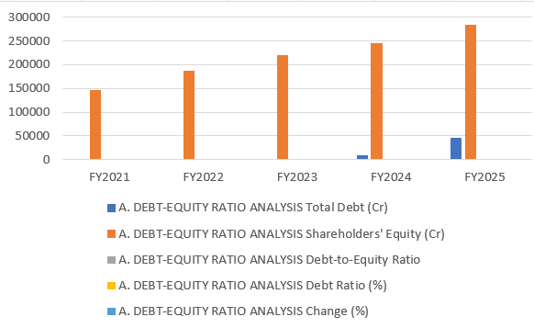

- DEBT RATIO ANALYSIS

Year | Total Liabilities (Cr) | Total Assets (Cr) | Debt Ratio (%) | Equity Ratio (%) | Change in Debt Ratio (%)
FY2021 | 168,467.80 | 315,170.70 | 53.45% | 46.55% | Base
FY2022 | 194,970.80 | 381,770.56 | 51.04% | 48.96% | ↓ 2.41%
FY2023 | 204,921.66 | 424,365.54 | 48.37% | 51.63% | ↓ 2.67%
FY2024 | 224,513.46 | 469,142.22 | 47.85% | 52.15% | ↓ 0.52%
FY2025 | 292,308.25 | 576,567.18 | 50.70% | 49.30% | ↑ 2.85%

Interpretation:
- Debt ratio (Total Liabilities/Total Assets) eased from 53.45% (FY2021) to a low of 47.85% (FY2024) before rising again to 50.70% (FY2025)
- Correspondingly, the equity ratio improved to a peak of 52.15% (FY2024) before easing to 49.30% (FY2025)
- The FY2025 uptick in the debt ratio aligns with the fresh long-term debt raised during the year
- Assets have remained financed in a broadly balanced ~50:50 mix of debt and equity throughout the period
- The capital structure indicates moderate financial risk, with no sustained trend toward over-leverage
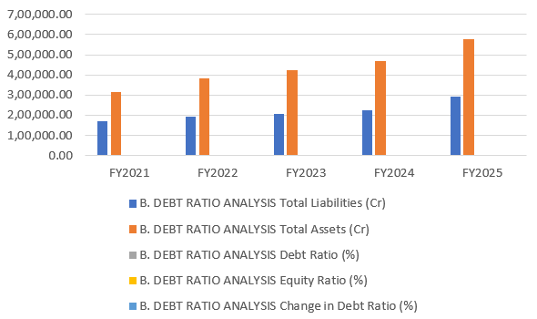

- CAPITAL STRUCTURE ANALYSIS

Year | Current Liabilities (Cr) | Long-Term Debt (Cr) | Total Debt (Cr) | Shareholders' Equity (Cr) | Total Capital (Cr)
FY2021 | 114,670.02 | 53,797.78 | 478.56 | 146,702.90 | 315,170.70
FY2022 | 139,359.11 | 55,611.69 | 437.94 | 186,799.76 | 381,770.56
FY2023 | 148,887.92 | 56,033.74 | 1,222.66 | 219,443.88 | 424,365.54
FY2024 | 159,183.14 | 65,330.32 | 8,600.87 | 244,628.76 | 469,142.22
FY2025 | 179,438.33 | 112,869.92 | 45,405.02 | 284,258.93 | 576,567.18

Interpretation:
- Total capital more than doubled over the period, from Rs.315,170.70 Cr to Rs.576,567.18 Cr
- Long-term debt jumped sharply in FY2025, from Rs.65,330.32 Cr to Rs.112,869.92 Cr, the steepest rise in the series
- Current liabilities grew steadily but at a slower pace than total capital, keeping short-term obligations proportionate
- Shareholders' equity remained the single largest component of the capital base throughout all five years
- The FY2025 shift toward greater long-term debt usage marks a notable change in financing strategy, likely to fund continued acquisitions
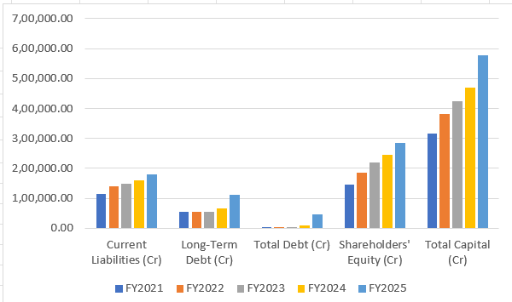

- INTEREST COVERAGE ANALYSIS

Year | EBIT/Operating Profit (Cr) | Finance Cost (Cr) | Interest Coverage Ratio | Times Change
FY2021 | 55,637.16 | 911.62 | 61.04x | Base
FY2022 | 74,462.76 | 1,198.53 | 62.14x | ↑ 1.80%
FY2023 | 70,089.72 | 1,376.62 | 50.92x | ↓ 18.10%
FY2024 | 76,334.96 | 1,754.75 | 43.47x | ↓ 14.68%
FY2025 | 81,345.16 | 2,038.42 | 39.91x | ↓ 8.19%

Interpretation:
- Interest coverage ratio declined steadily from 61.04x (FY2021) to 39.91x (FY2025)
- The decline was driven by finance costs more than doubling while EBIT/operating profit grew at a slower pace
- Even at its lowest point, coverage of 39.91x remains far above the conventional safety benchmark of 3x, indicating negligible default risk
- FY2023 and FY2024 saw the sharpest year-on-year declines (-18.10% and -14.68% respectively)
- The trend signals rising financial risk at the margin as debt levels increase, though absolute coverage remains very comfortable
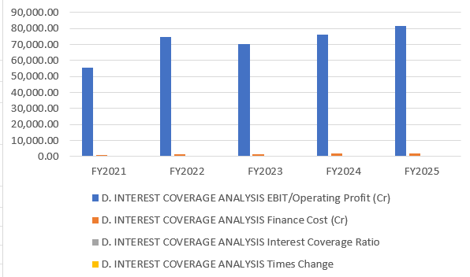

- DEBT SERVICE COVERAGE ANALYSIS

Year | Operating Cash Flow (Cr) | Total Debt Repayment (Cr)
FY2021 | 48,950.45 | 1,390.18
FY2022 | 65,341.82 | 1,046.47
FY2023 | 61,178.56 | 1,783.38
FY2024 | 67,824.93 | 9,355.62
FY2025 | 74,297.41 | 47,443.44

Interpretation:
- Operating cash flow grew consistently every year, from Rs.48,950.45 Cr to Rs.74,297.41 Cr
- Total debt repayment obligations spiked dramatically in FY2025, to Rs.47,443.44 Cr from just Rs.9,355.62 Cr in FY2024
- Even with the FY2025 repayment surge, operating cash flow of Rs.74,297.41 Cr comfortably exceeds the repayment obligation, implying a debt service coverage of roughly 1.6x
- The sharp rise in repayments mirrors the large debt drawn down in FY2024-FY2025
- Cash flow generation remains strong enough to service the higher debt load, but the shrinking cushion versus FY2021-FY2023 levels warrants monitoring
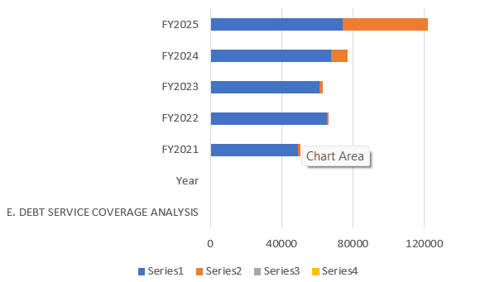

- LEVERAGE RATIOS SUMMARY

Metric | FY2021 | FY2022 | FY2023 | FY2024 | FY2025
D/E Ratio | 0.0033:1 | 0.0023:1 | 0.0056:1 | 0.0352:1 | 0.1597:1
Debt Ratio (%) | 53.45% | 51.04% | 48.37% | 47.85% | 50.70%

Interpretation:
- The D/E ratio trend shows a shift from near-zero leverage to a moderate 0.1597:1 by FY2025
- The debt ratio stayed range-bound between 47.85% and 53.45%, indicating a broadly stable overall financing mix despite the new debt
- FY2024 marked the lowest leverage point (D/E of 0.0352:1) before the reversal in FY2025
- The company has moved from an almost equity-only structure toward a more balanced, though still conservative, capital structure
- Overall leverage remains modest relative to typical industry norms for large IT/services firms, leaving headroom for further borrowing if needed
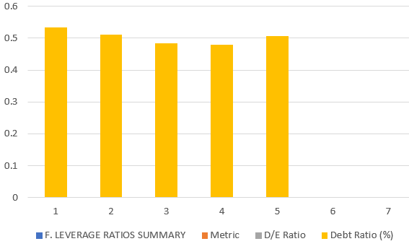

CHAPTER – 5

FINDINGS, SUGGESTIONS AND CONCLUSION

5.1 FINDINGS OF THE STUDY

1. Strong Financial Growth:
Accenture Ltd. showed strong overall financial growth during FY2021–FY2025. Total assets increased by 82.8%, while revenue increased by 50.3% and net profit increased by 42.5%. This indicates continuous business expansion and a positive financial position.

2. Improved Liquidity Position:
The liquidity position fluctuated during the study period. Both the current ratio and quick ratio declined in FY2024 but recovered significantly in FY2025 to 1.42:1 and 1.30:1 respectively, indicating an improvement in the company's short-term financial position.

3. Stable but Pressured Profitability:
Although gross profit and net profit increased in absolute terms, the gross profit margin declined from 28.06% to 25.37%. The net profit margin also declined slightly from 11.85% to 11.24%, indicating increasing cost and margin pressure.

4. Declining Return Ratios:
ROA declined from 13.87% in FY2021 to 11.91% in FY2025, while ROE declined from 29.81% to 23.55%. This indicates that assets and shareholders' equity increased faster than net profit, reducing returns on the respective resources.

5. Conservative but Increasing Leverage:
The company maintained a broadly stable capital structure, but its use of debt increased considerably in FY2024 and FY2025. Despite this increase, the Debt-Equity Ratio remained conservative and the Interest Coverage Ratio remained strong at 39.91 times in FY2025.

5.2 SUGGESTIONS OF THE STUDY

1. The company should focus on controlling operating and delivery costs to improve its declining gross profit margin.

2. Accenture Ltd. should maintain adequate cash and current assets to ensure a strong liquidity position and avoid a recurrence of the weaker liquidity position observed in FY2024.

3. The company should carefully manage its increasing debt and finance costs and ensure that additional borrowing generates adequate returns.

4. Management should improve asset utilisation and productivity so that the increasing asset base contributes proportionately to revenue and profitability.

5. The company should regularly evaluate the performance of acquisitions, particularly because goodwill and intangible assets form a significant portion of total assets.

6. Accenture Ltd. should take measures to improve and sustain ROA and ROE by increasing profitability and making more efficient use of assets and shareholders' funds.

7. The company should continue regular monitoring of liquidity, profitability, solvency and cash flows to identify financial risks early and maintain long-term financial stability.

5.3 CONCLUSION

The study concludes that Accenture Ltd. maintained a strong overall financial position during FY2021–FY2025. The company recorded substantial growth in total assets, revenue and net profit, indicating continuous business expansion and satisfactory financial performance. The improvement in liquidity during FY2025 further strengthened its short-term financial position.

However, the analysis also indicates certain areas requiring attention. The decline in gross profit margin, ROA and ROE shows that increasing resources and business scale have not resulted in proportionate improvement in returns. At the same time, finance costs and debt increased considerably during the later years of the study period.

Overall, Accenture Ltd. can be considered financially stable, profitable and growth-oriented, with strong cash-flow generation and a conservative level of leverage. The company can further improve its financial efficiency by controlling costs, improving asset utilisation, managing debt prudently and ensuring that its acquisition-led growth generates adequate returns.

ARTICLE REFERENCES

Article / Source 1
Title: The Relationship Between Financial Performance, Firm Size, Leverage, and
Corporate Social Responsibility: A Case Study of Accenture Plc
Authors: Akinbola Olawale and Bolaji Akinbola
Publisher / Journal: World Journal of Advanced Research and Reviews
Year: 2024
Topic: Financial performance, Return on Equity, revenue, leverage and Accenture Plc.
Link: https://wjarr.com/sites/default/files/fulltext_pdf/WJARR-2024-3166.pdf
The article is directly related to Accenture and uses secondary financial data. The full text is openly available under a Creative Commons licence.

Article / Source 2
Title: Accenture Fiscal 2025 Annual Report
Publisher: Accenture plc
Year: 2025
Topic: Financial statements, financial position, revenue, operating income, net income, assets, liabilities and shareholders' equity.
Link: https://www.accenture.com/content/dam/accenture/final/accenturecom/document-4/Annual-Report-2025.pdf
The report contains Accenture's consolidated financial statements and is an appropriate primary source for the financial analysis in this project.

Article / Source 3
Title: Accenture Fiscal 2024 Annual Report
Publisher: Accenture plc
Year: 2024
Topic: Financial performance, financial position, revenue, income, assets, liabilities, equity and cash flows.
Link: https://www.accenture.com/ae-en/about/company/annual-report
The official Accenture annual-report archive provides access to the Fiscal 2024 report.

Article / Source 4
Title: Accenture Fiscal 2023 Annual Report
Publisher: Accenture plc
Year: 2023
Topic: Financial performance, consolidated financial statements, assets, liabilities, equity, revenue and cash flows.
Link: https://www.accenture.com/ae-en/about/company/annual-report
The Fiscal 2023 annual report is available through Accenture's official annual-report archive.

Article / Source 5
Title: Accenture Fiscal 2022 Annual Report
Publisher: Accenture plc
Year: 2022
Topic: Financial performance, financial position, revenue, profitability, assets, liabilities and shareholders' equity.
Link: https://www.accenture.com/ae-en/about/company/annual-report

The Fiscal 2022 annual report is available through Accenture's official annual-report archive.

PRIMARY SOURCE FOR THE FIVE-YEAR FINANCIAL DATA
Source: Accenture Official Annual Reports
Financial Years: FY2021, FY2022, FY2023, FY2024 and FY2025
Publisher: Accenture plc
Purpose: To obtain the actual financial figures required for Comparative Statement
Analysis, Common-size Statement Analysis, Trend Analysis, Current Ratio, Quick Ratio, Net Profit Ratio, Operating Profit Ratio, ROA, ROE, ROCE, Debt–Equity Ratio and Asset Turnover Ratio.
Official Source: Accenture Annual Reports

